**Q1: Find out the total no of users in the database-**

**

**Q3.** **Do male facebook users tend to have more friends for female users-**

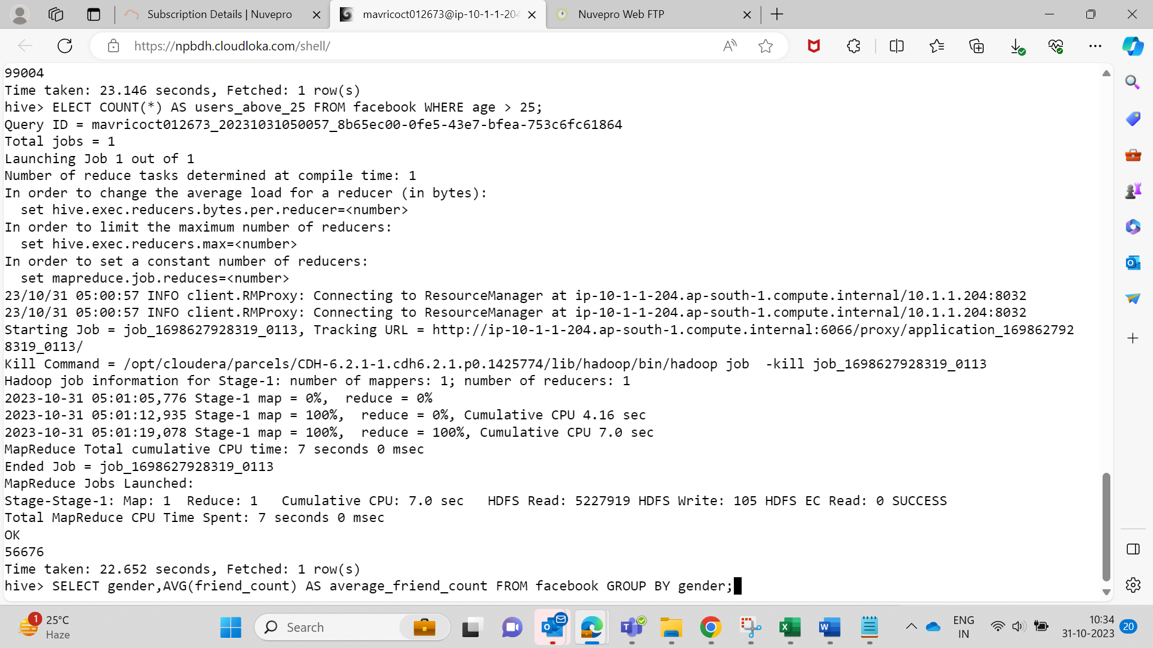

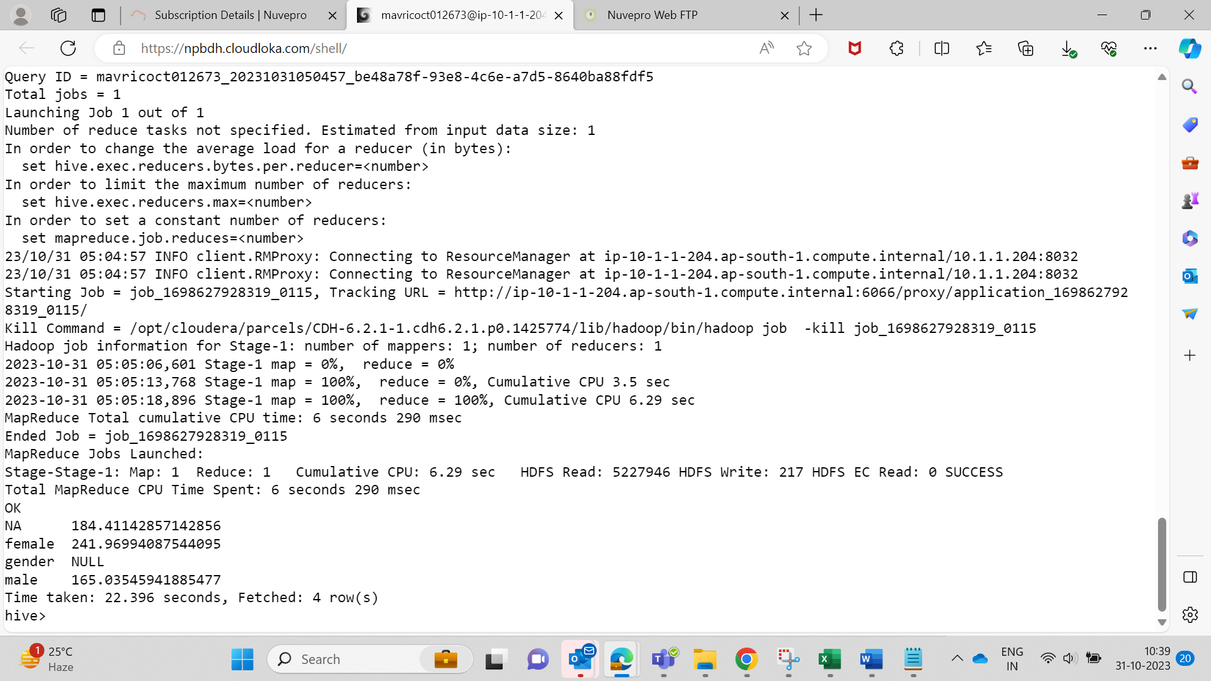

**From the result, it appears that female users have a higher average friend count compared to male users.  
  
Q4. How many likes do young people receive on facebook as opposed to old people-**

**SELECT**

**age_group,**

**SUM(likes_received) AS total_likes_received**

**FROM (**

**SELECT**

**CASE**

**WHEN age < 30 THEN 'Young'**

**ELSE 'Old'**

**END AS age_group,**

**likes_received**

**FROM facebook**

**) subquery**

**GROUP BY age_group;**

**Q5.Find out the count of facebook users for each birthday month-**

**Q6: Do young members use mobile phones or computers for facebook browsing-**

**WITH age_device AS (**

**SELECT**

**CASE**

**WHEN age < 30 THEN 'Young'**

**ELSE 'Old'**

**END AS age_group,**

**CASE**

**WHEN mobile_likes > 0 THEN 'Mobile'**

**ELSE 'Computer'**

**END AS device_type**

**FROM facebook**

**)**

**SELECT**

**age_group,**

**device_type,**

**COUNT(*) AS user_count**

**FROM age_device**

**GROUP BY age_group, device_type;**

**Q7: Do adult members use mobile phones or computers for facebook browsing-**

**SELECT**

**age_group,**

**device_type,**

**COUNT(*) AS user_count**

**FROM (**

**SELECT**

**CASE WHEN age >= 18 THEN 'Adult' ELSE 'Not Adult' END AS age_group,**

**CASE WHEN mobile_likes > 0 THEN 'Mobile' ELSE 'Computer' END AS device_type**

**FROM facebook**

**) subquery**

**GROUP BY age_group, device_type;**

